Learning Management System

Use-Case-Realization Specification: Manage Courses

Version <1.0>

Revision History

| **Date** | **Version** | **Description** | **Author** |
| --- | --- | --- | --- |
| 28/11/2024 | 1.0 | Final version | Nguyễn Thị Hiền Anh |

Table of Contents

1. Introduction 2

1.1 Purpose 2

1.2 Scope 2

1.3 Definitions, Acronyms, and Abbreviations 2

1.4 References 2

1.5 Overview 2

2. Flow of Events—Design 2

3. Derived Requirements 2

Use-Case-Realization Specification: Manage Courses

# Introduction

## Purpose

This is Use-Case Realization Specification of the use case: Manage Course

## Scope

This document describes how the use case for managing courses by admin on the system is realized within the design model, specifically sequence diagram and class diagram.

## Definitions, Acronyms, and Abbreviations

Admin: or administrator, who manages the system.

## References

NA.

## Overview

Use-Case Realization Specification of Manage Announcement is provided in full. In this document, it will be summarized into a written description. There are sequence and class diagrams that show how the use case is implemented.

# Flow of Events—Design

## Sequence diagram

* + 1. **Access and View Course Management View**

Initiate the Course Management View and choose the page number to see more courses.

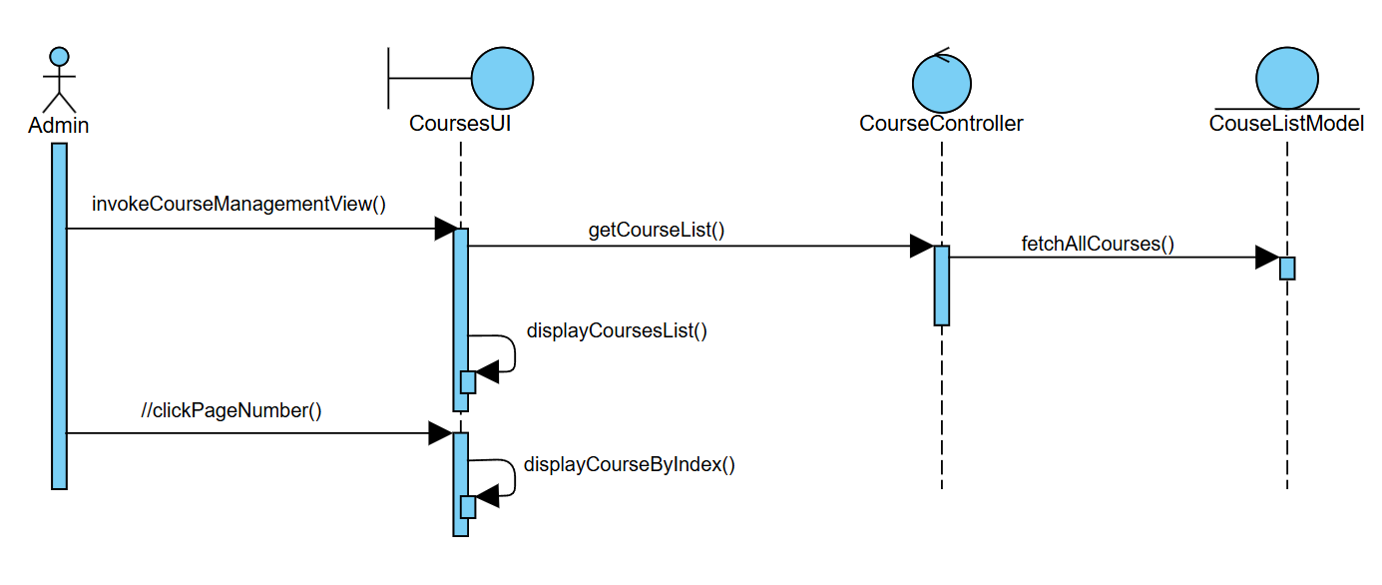

Search for courses by keywords, including Course Name and Course ID.

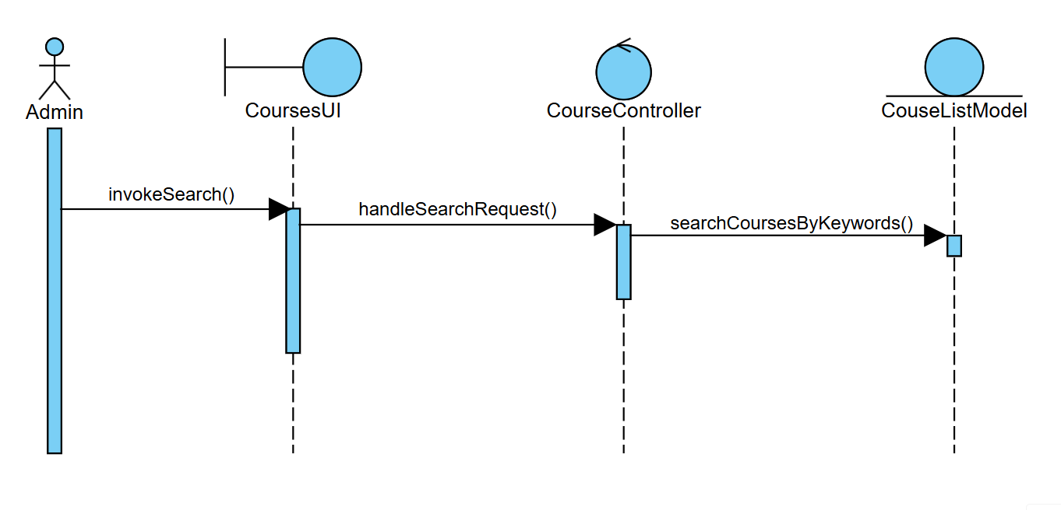

The admin can sort the course based on references (latest-oldest; oldest-latest; recently added)

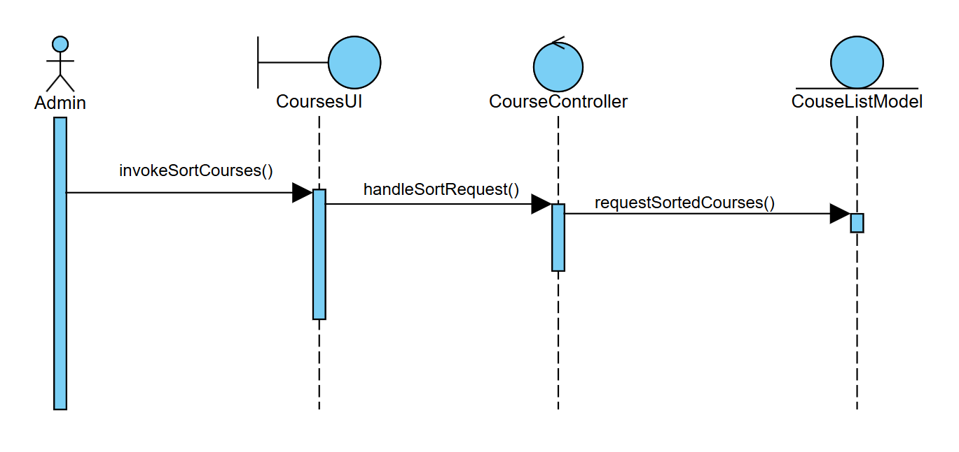

The admin can view course details when clicking the “View” button, but is not allowed to edit in this view.

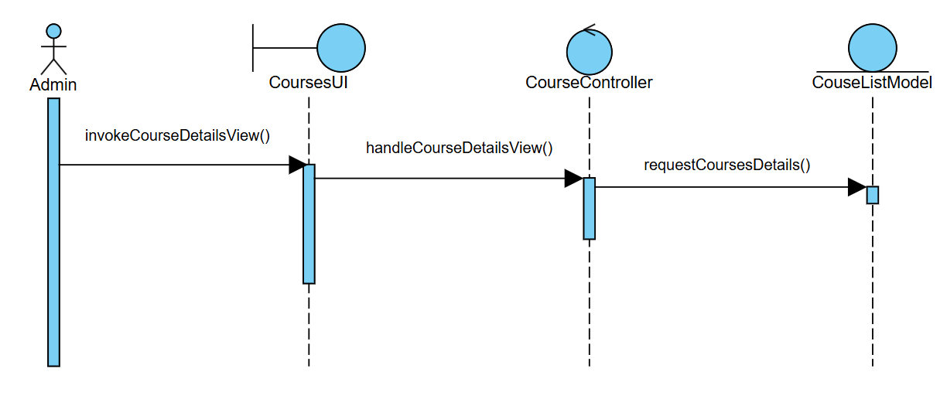

**2.1.2. Create course**

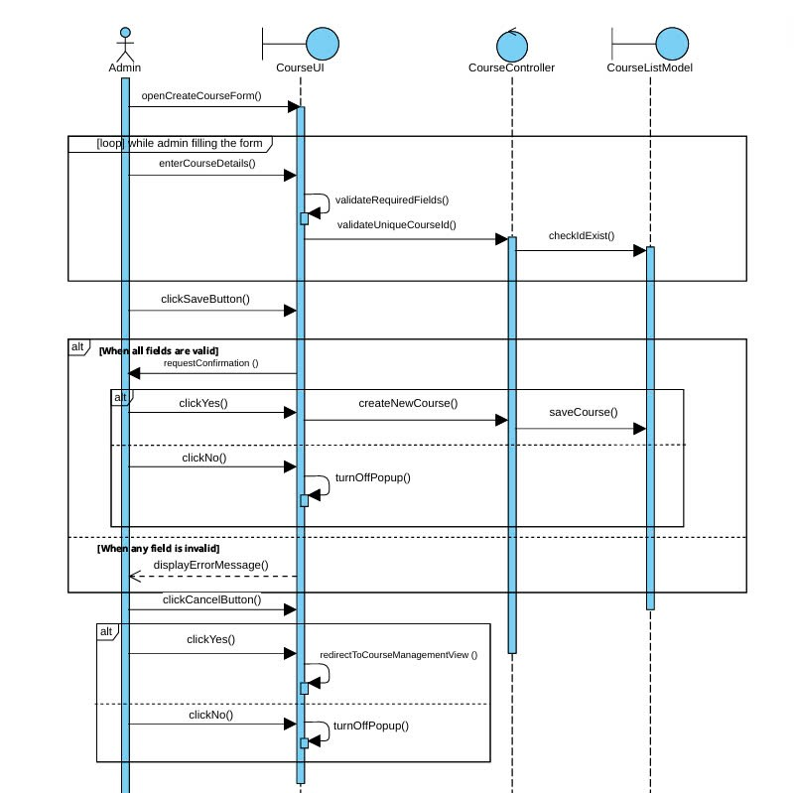

**2.1.3. Edit courses**

The flow of editing courses is similar to creating courses; the admin must fill in the required fields so he/she is not allowed to delete data from those fields and let them empty. The course ID might be changed but still needs to be unique, so there are still validation and checking uniqueness processes constantly while the admin is typing in the form and editing information in the form.   
The admin can also adjust the member list as in creating a course by adding or removing a member account from the list.

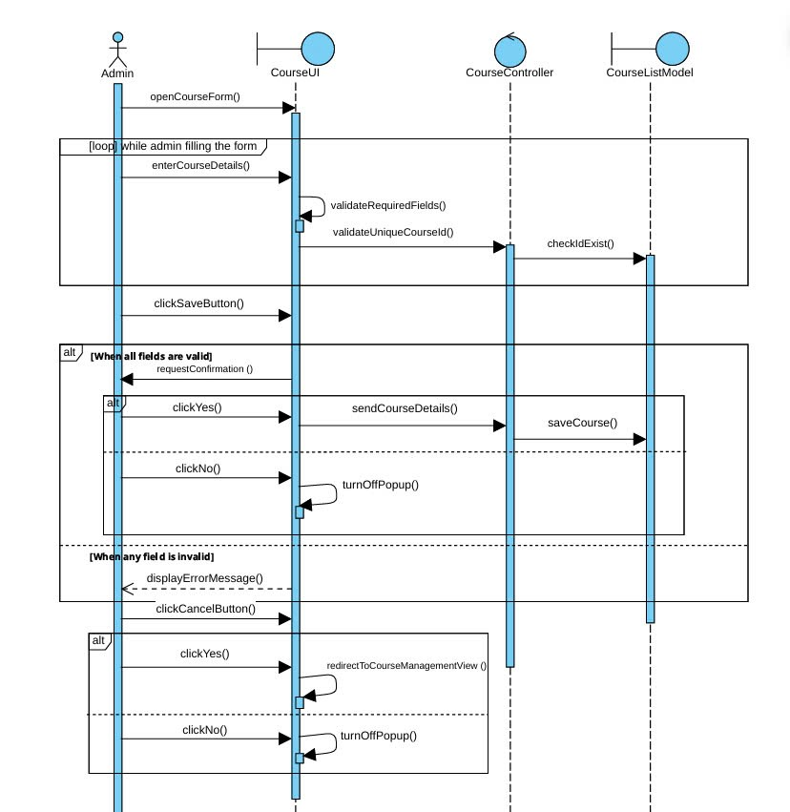

**2.1.4. Delete courses**

When the admin hovers on the card, the three buttons will appear, including the “Delete” button. When the admin clicks that button, the system must check if the course has ended yet; if it hasn’t, the course is not allowed to be deleted. If it is ended, the system will pop up a confirmation whether the admin really wants to delete the course and only delete the course when the admin confirms again to.

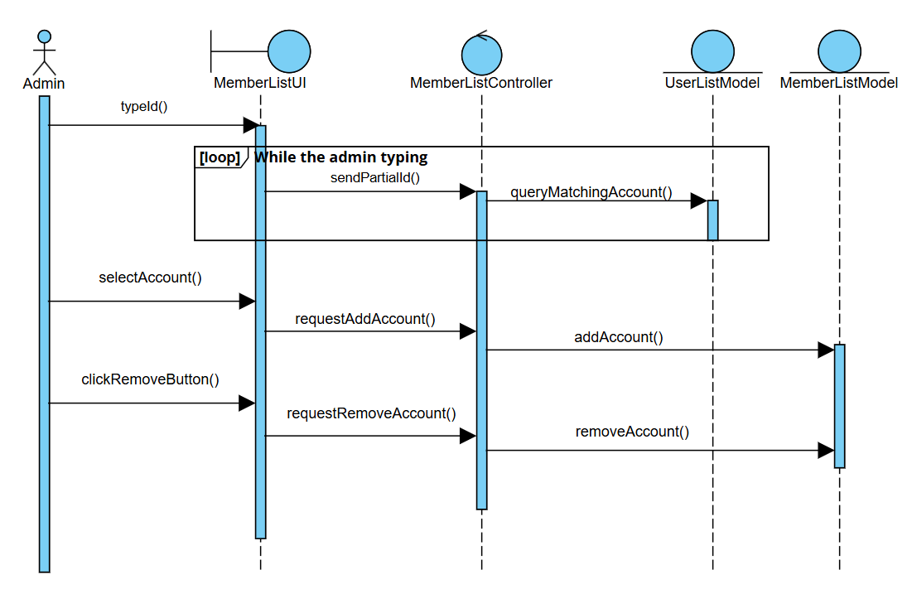

## Class diagram

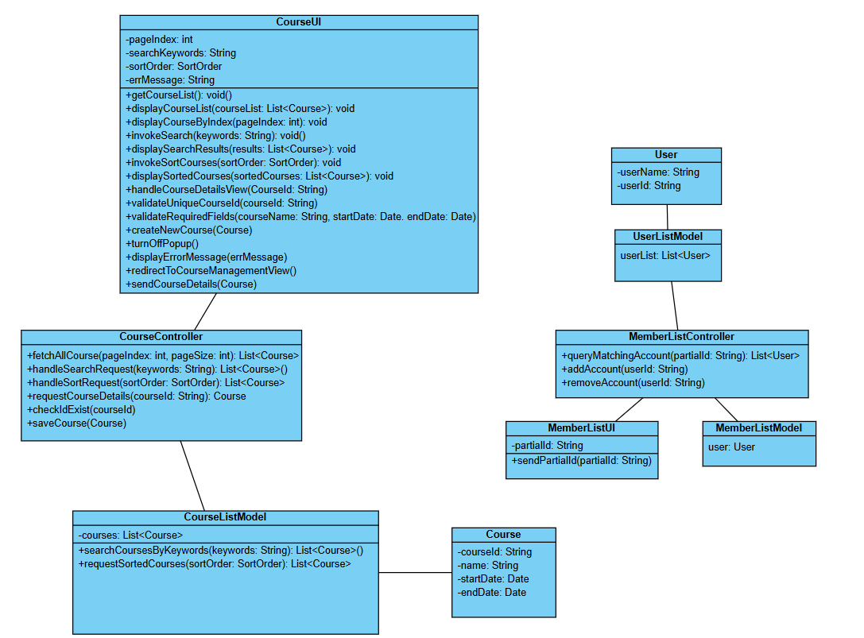

# Derived Requirements

NA.